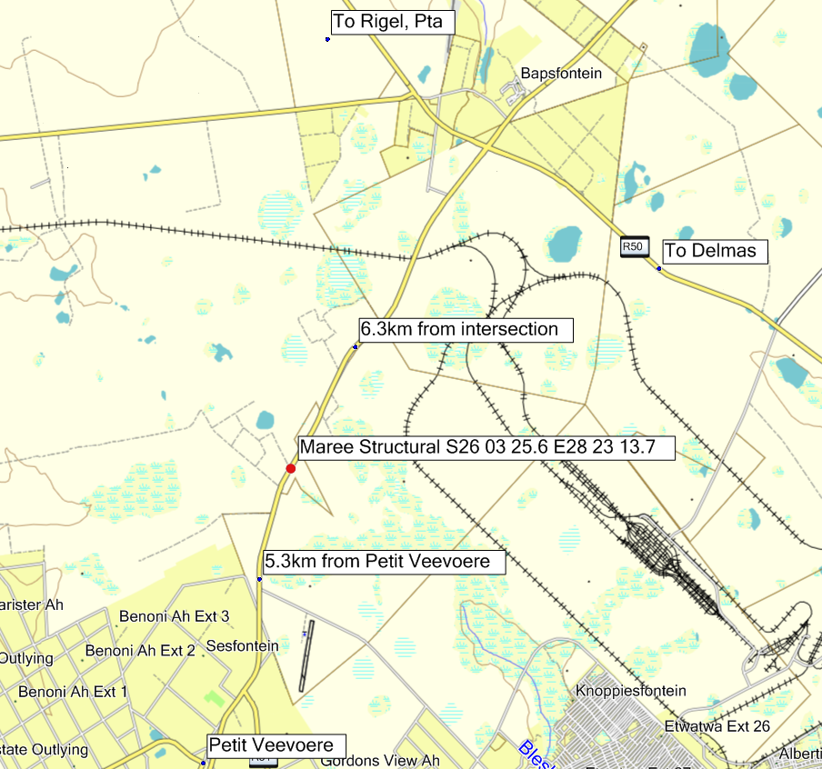
Deliveries
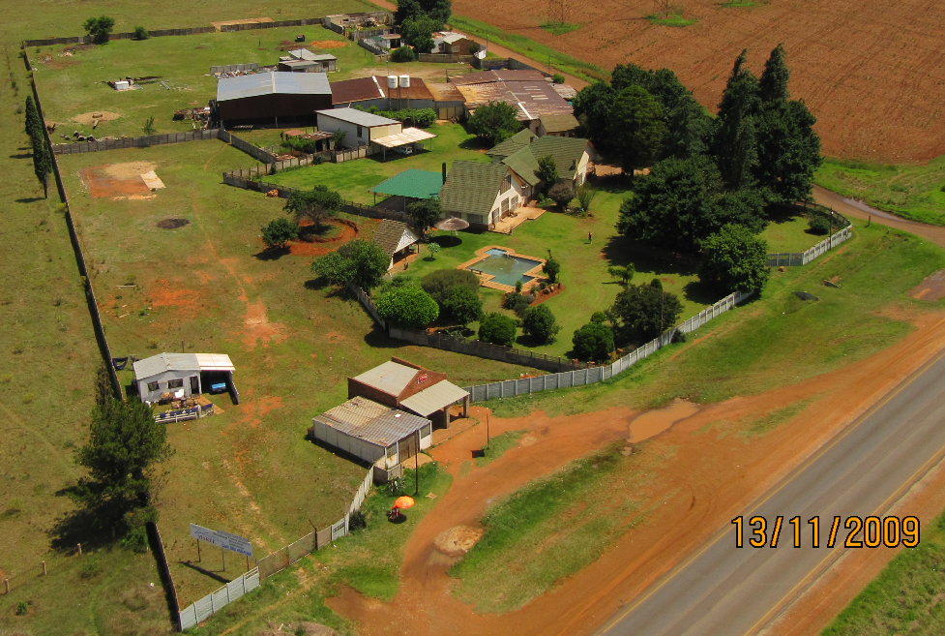
Entrance
Hillrise Oasis

MAREE Structural
Plot 35, Pretoria Rd, Hillrise Kempton Park
Look out for Hillrise Oasis on premises Cell: 082 4585365

